FinSight: Enterprise Credit Risk Analytics and Automated Loan Underwriting Engine

Rajendra Phalani
Department of Computer Science and Engineering,
Koneru Lakshmaiah Education Foundation (KLEF),
Hyderabad, Telangana, India.
polurirajendradspkumar6@gmail.com
Mallikarjun
Department of Computer Science and Engineering,
Koneru Lakshmaiah Education Foundation (KLEF),
Hyderabad, Telangana, India.
Praveen
Department of Computer Science and Engineering,
Koneru Lakshmaiah Education Foundation (KLEF),
Hyderabad, Telangana, India.

Guide: Dr. N. Sunanda, Associate Professor
Department of Computer Science and Engineering
Koneru Lakshmaiah Education Foundation
Hyderabad, Telangana, India.
Abstract—Credit risk assessment and loan underwriting are central functions of banks, non-banking financial companies, and digital lenders, yet manual review remains slow, inconsistent across reviewers, and hard to audit. This paper presents FinSight, an enterprise credit risk analytics and automated loan underwriting engine that integrates feature engineering, probability of default estimation with three model families, a credit score on a scale of 300 to 900 with an eight-step grade and risk-based pricing, a configurable policy layer of knockout rules, soft flags, and cut-offs, and factor-level explainability in one modular pipeline. The engine is implemented as a React and TypeScript web application with six modules, namely a portfolio dashboard, a live loan underwriter with bank-statement intake, a model benchmarking laboratory, a policy rules editor, a persistent loan ledger with batch decisioning, and an academic showcase, together with a Python pipeline that generates a synthetic dataset of ten thousand applicants. In the reference benchmark of the project, the champion gradient-boosted variant reaches an AUC-ROC of 0.884 and a KS statistic of 52.6 percent. Function-level testing of the real service modules on ten applicants and twenty-nine boundary and configuration cases showed that policy thresholds are applied exactly at their boundaries. The benchmark figures come from calibrated approximations and synthetic data rather than from models trained on real lending records, and the paper discusses this limitation together with a route to production use.
Keywords—credit risk, probability of default, loan underwriting, explainable AI, SHAP, XGBoost, policy engine, credit scoring

Introduction
Lending institutions such as banks, non-banking financial companies (NBFCs), and digital lenders evaluate a large volume of loan applications, each requiring an assessment of the applicant’s ability and likelihood to repay. Although digital application forms have made data collection easier, the risk assessment stage still involves considerable manual effort: a reviewer may verify credit bureau history, compute income and debt ratios, cross-check documents, and apply lending policy, often separately for each loan product. Two underwriters can reach different decisions on the same file, reasons are rarely recorded in a structured way, and the institution cannot easily show a regulator why an applicant was approved or declined. Regulatory frameworks such as the Basel Internal Ratings-Based approach [1] and the fair-practice expectations of the Reserve Bank of India (RBI) [2] emphasise calibrated default probabilities, rating grades, and auditability.
Recent research has addressed parts of this problem. Machine learning on both bureau data and behavioral or transactional signals has been studied for credit scoring [3]; explainable artificial intelligence techniques such as SHAP (SHapley Additive exPlanations) and LIME (local interpretable model-agnostic explanations) have been applied to make credit risk models transparent [4]; ensemble and deep-learning models have been benchmarked for default prediction [5]; and ensemble methods combined with class-imbalance handling have been shown to improve default prediction [6]. These studies, however, concentrate on model performance or explanation rather than on a complete, policy-driven underwriting workflow.
The problem addressed here is therefore the lack of a unified tool that can ingest applicant data, score credit risk, apply lending policy automatically, explain each decision, and present portfolio-level risk in one workflow. This paper presents FinSight, a working enterprise credit risk analytics and automated loan underwriting engine that brings these elements together in one modular application. Its main contributions are:
- a feature-engineering and scoring pipeline that estimates a probability of default (PD) with three selectable model families and converts it to a 300–900 score, an eight-step credit grade, and a risk-based interest rate;
- a configurable policy layer of knockout rules, soft flags, and score cut-offs, kept separate from the models, that issues an approved, referred, or rejected decision together with a limit and a reason;
- decision-level factor attribution and a printable audit certificate, together with portfolio analytics, a model benchmarking laboratory, and a persistent loan ledger with batch decisioning; and
- a function-level evaluation of the project’s own service modules on ten applicants and twenty-nine boundary and configuration cases, with an explicit account of what the reported benchmark figures do and do not show.
The remainder of the paper is organized as follows. Section II reviews related work, Section III describes the architecture, Section IV presents the methodology, Section V summarizes the implementation, Section VI reports results and discussion, and Sections VII to IX cover limitations, future work, and conclusions.

Related Work

Scoring Models and Benchmarks
Abi investigated machine learning models for credit scoring and loan default prediction using behavioral and transactional signals, such as spending patterns and payment timing, in addition to traditional bureau records [3]. The study reported that combining alternative data sources improves predictive richness and addressed privacy, class imbalance, and interpretability using SHAP and LIME. Chang et al. compared random forest, AdaBoost, XGBoost, and neural networks for predicting credit card customer default and found gradient-boosted models to perform strongly [5]; the benchmark is limited to a single loan product and does not integrate scoring into a decisioning or monitoring system. Akinjole et al. compared random forest, decision tree, support vector machines, XGBoost, AdaBoost, and a multi-layer perceptron for loan default prediction and evaluated resampling techniques such as the synthetic minority oversampling technique (SMOTE) and adaptive synthetic sampling (ADASYN), finding that balanced training data and ensemble methods, particularly stacking, improve performance [6]. Gade and Kunwar proposed a framework for credit risk assessment and loan default detection on structured borrower attributes such as income, employment type, loan amount, and repayment history, using a synthetically generated dataset [7]; it does not include automated policy-based decisioning, explainability reporting, or portfolio monitoring.

Explainable Credit Decisions
Shreya and Pathak presented an explainable AI system for credit risk assessment that combines XGBoost, LightGBM, and random forest with SHAP and LIME to generate applicant-specific explanation reports [4], emphasizing transparency in individual lending decisions. SHAP itself rests on Shapley-value feature attributions [8]. For an enterprise underwriting tool, however, explainability alone is not sufficient; it must be paired with automated policy rules and portfolio-level monitoring.

Research Gap
The literature generally emphasizes one aspect of credit risk analytics: predictive accuracy with alternative data, explainability of individual decisions, algorithm benchmarking, or class-imbalance handling (Table I). Few works integrate data ingestion, risk scoring, automated policy-based decisioning, explainability, and portfolio-level monitoring in one enterprise-oriented workflow. FinSight addresses this gap by combining these stages in one modular pipeline.
- Related Work and the Gap Addressed by FinSight
Work | Main method | Gap addressed by FinSight
Abi [3] | ML with behavioral and transactional data | Adds an automated, policy-driven decision layer
Shreya and Pathak [4] | XGBoost, LightGBM, random forest with SHAP and LIME | Embeds explainability in an end-to-end decision and monitoring pipeline
Chang et al. [5] | Benchmark of ML and DL models on credit card data | Extends benchmarking into a deployable underwriting engine with decisioning
Akinjole et al. [6] | Ensembles with class-imbalance handling | Adds dashboard, explainability reporting, and policy decisioning
Gade and Kunwar [7] | ML framework on structured borrower data | Adds a rules engine, explainability, and portfolio monitoring

System Architecture and Workflow
FinSight follows a three-layer architecture (Fig. 1). The presentation layer renders six modules, the decision layer holds all business logic, and the data layer supplies typed datasets, the browser-persisted applicant ledger, and the offline Python pipeline. Dependencies point downwards only: components call services, and services depend on types and data, never on components.
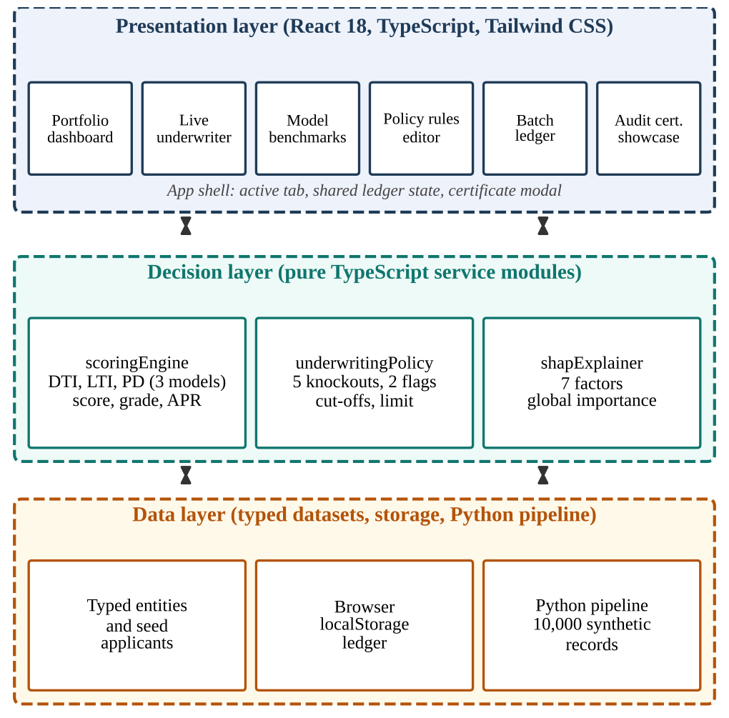
- Layered architecture of FinSight.

Presentation Layer
A single application shell keeps four pieces of state: the active module, whether the team dialog is open, the decision selected for the audit certificate, and the shared applicant ledger, which is initialized from the browser’s localStorage and written back on every change. Each module is an independent React component that receives only the callbacks it needs. Decisions are never stored; they are derived from the inputs with memoized functions, so the display is always consistent with the inputs and every slider movement produces an immediate new decision.

Decision Layer
Given an applicant record, the scoring engine engineers features and estimates the PD, the policy module applies knockout and flag rules and the score cut-offs to reach a decision, and the explainer produces factor attributions. All functions are deterministic and free of side effects, which makes them straightforward to test and to relocate behind a server interface.

Data Layer and Workflow
Shared types define the entities Applicant, UnderwritingResult, ShapFactor, PolicyRule, ModelMetric, and PortfolioStats. An applicant produces one or more underwriting results, each owning a set of factor attributions, and policy rules are evaluated for every result. End to end, the workflow is data ingestion, cleaning, feature engineering, model scoring, policy evaluation, decision, explanation, and finally the portfolio dashboard and ledger. The modular structure allows the scoring model or the policy rules to be replaced without redesigning the application.

Methodology

Feature Engineering
The debt-to-income ratio (DTI) includes the estimated instalment of the requested loan. The new equated monthly instalment (EMI) is computed with the reducing-balance formula at a fixed annual rate of 12 percent, that is, r = 0.01 per month, over the requested tenure of n months for a requested amount P:
EMI_{new} = P r (1 + r)^{n} / ((1 + r)^{n} − 1) (1)
With E the existing monthly EMI and I the monthly net income, the DTI in percent and the loan-to-income ratio (LTI), which divides the request by annual income floored at Rs. 10,000, are
DTI = 100 (E + EMI_{new}) / max(I, 1000) (2)
LTI = P / max(12I, 10000) (3)
Other inputs are standardized around reference points: the credit bureau (CIBIL) score, on a scale of 300–900, is centered at 650 with scale 100, DTI at 35 percent with scale 15, card utilization at 30 percent with scale 25, and employment tenure at 4 years with scale 3. Employment type adds a fixed adjustment to the log-odds: −0.55 for government salaried, −0.25 for corporate salaried, +0.15 for self-employed, and +0.40 for gig or contractual workers. In the champion model, banking conduct adds 0.45 to the log-odds for every inward cheque or electronic clearing service (ECS) bounce in the last six months, and a liquidity term lowers the log-odds by 0.30 when the ratio of average monthly balance to the requested loan exceeds 0.35 and raises it by 0.20 when the ratio is below 0.05.

Probability of Default
The PD is the output of a logistic transform of a model-specific log-odds z, clamped between 0.3 percent and 88 percent:
PD = 1 / (1 + e^{−z}) (4)
Three variants are implemented so that users can compare model behavior live (Table II): a logistic regression baseline [9], a random forest challenger [10], and an XGBoost-style gradient-boosted champion [11]. The interaction and super-prime terms of the champion allow it to capture non-linear effects that the linear baseline cannot, and only the champion uses the banking-conduct terms. These log-odds functions are calibrated approximations that mimic the behavior of the three model families inside the browser; they are not models fitted to lending data (Section VII).
- Model Variants Implemented in the Scoring Engine
Model | Role | Log-odds structure (summary)
Logistic regression | Baseline | Linear: intercept −2.8; bureau −0.85, DTI +0.65, utilization +0.55, delinquencies +0.90, inquiries +0.35, tenure −0.30; plus employment adjustment
Random forest | Challenger | Threshold steps from intercept −2.9 for bureau below 620, DTI above 45, utilization above 70, delinquencies ≥ 2, inquiries ≥ 3; reduction for tenure above 5 years; 0.8 × employment adjustment
XGBoost-style | Champion | Additive terms from intercept −3.1 (bureau −1.05, DTI +0.75, utilization +0.65, inquiries +0.38, tenure −0.42, LTI +0.30); delinquency term (+1.6, +0.6, −0.4); interaction +0.75 when DTI > 45 and utilization > 65; super-prime −0.8 when bureau > 780 and DTI < 30; employment, bounce, and liquidity terms

Score, Grade, and Pricing
Following the log-odds scaling used by bureau scores [12], the PD, expressed as a fraction, is converted to a score bounded to 300–900:
S = 600 + (25 / ln 2) ln((1 − PD) / PD) − 15 (5)
The PD is also mapped to one of eight credit grades, and the grade fixes a spread over a base lending rate of 8.5 percent to give the suggested annual percentage rate (APR), as listed in Table III.
- Grade, Spread, and APR Mapping
Grade | PD range (%) | Spread (%) | APR (%)
AAA | < 1.5 | 1.75 | 10.25
AA | 1.5 to < 3.0 | 2.50 | 11.00
A | 3.0 to < 5.0 | 3.50 | 12.00
BBB | 5.0 to < 8.0 | 4.75 | 13.25
BB | 8.0 to < 12.0 | 6.50 | 15.00
B | 12.0 to < 18.0 | 8.50 | 17.00
CCC | 18.0 to < 28.0 | 11.00 | 19.50
D | ≥ 28.0 | 14.50 | 23.00

Policy Engine and Decision Logic
Seven default rules are defined as data records (field, operator, threshold, action, enabled), so each can be switched off or re-tuned without changing code: five knockouts that cause automatic rejection and two borderline flags that force manual review (Table IV). After the rules are evaluated, the decision follows a fixed order of precedence (Fig. 2). (1) Any enabled knockout gives REJECTED. (2) Otherwise, a PD above 10.5 percent or a score below 560 gives REJECTED for excess credit risk. (3) Otherwise, a PD at or below 4.8 percent, a score of at least 665, and no soft flags gives APPROVED, which is straight-through processing (STP). (4) Everything else is REFERRED to a senior underwriter, either because a flag fired or because the applicant sits in the near-prime band between the cut-offs.
- Default Policy Rules
Rule | Condition | Outcome
Minimum bureau cut-off | CIBIL score < 580 | Reject
Maximum DTI | DTI > 58 percent | Reject
Delinquency cap | > 2 in 24 months | Reject
Minimum income | < Rs. 20,000 per month | Reject
Cheque or ECS bounce cap | ≥ 2 in 6 months | Reject
High inquiry velocity | ≥ 4 inquiries in 6 months | Refer
High card utilization | > 80 percent | Refer

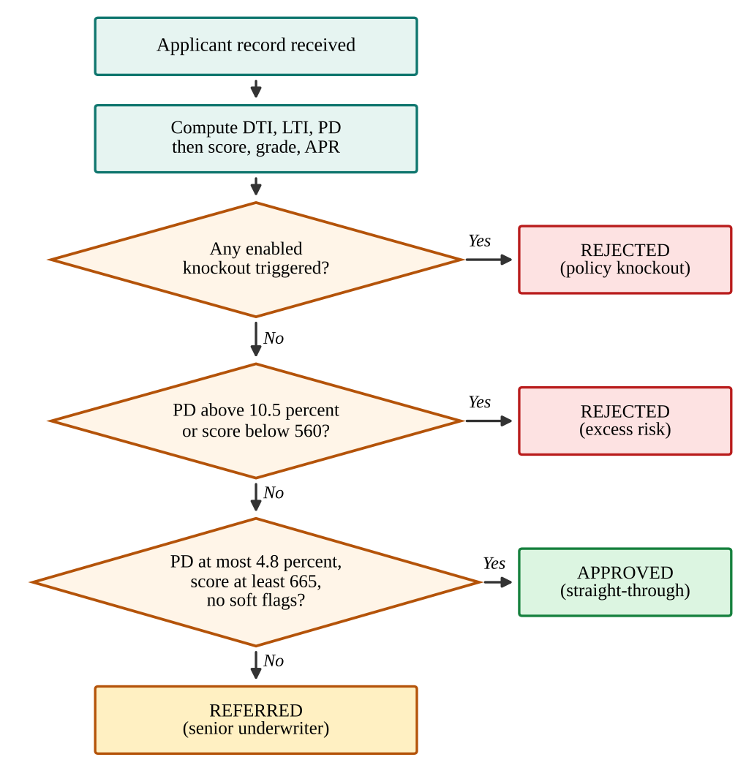
- Order of policy evaluation in the underwriting decision.
The approved limit depends on the outcome: zero when rejected; for referrals, a conservative counter-offer equal to the smaller of 75 percent of the request and twelve months of income; and for approvals, the requested amount, increased to 115 percent (rounded to the nearest Rs. 10,000) for grades AAA and AA. Keeping rules and cut-offs outside the models lets risk teams change lending criteria without retraining.

Explainability
The explainer decomposes each decision into seven factors: bureau score, DTI, 24-month delinquencies, card utilization, employment stability, inquiry velocity, and bank-account conduct. Each factor receives a signed point contribution (positive raises the score and lowers risk), a risk direction, a rank, and a plain-language explanation, and the list is sorted by absolute impact. For example, zero delinquencies add 45 points whereas two or more subtract 90, and a DTI up to 30 percent adds 35 points whereas a DTI above 50 percent subtracts 65. These attributions follow the additive logic of SHAP [8] but are rule-based point bands, not Shapley values computed from a fitted model. A global importance ranking (Fig. 3) supports the benchmark view, and a printable audit certificate records the decision, the policy findings, and the factor attribution for review.
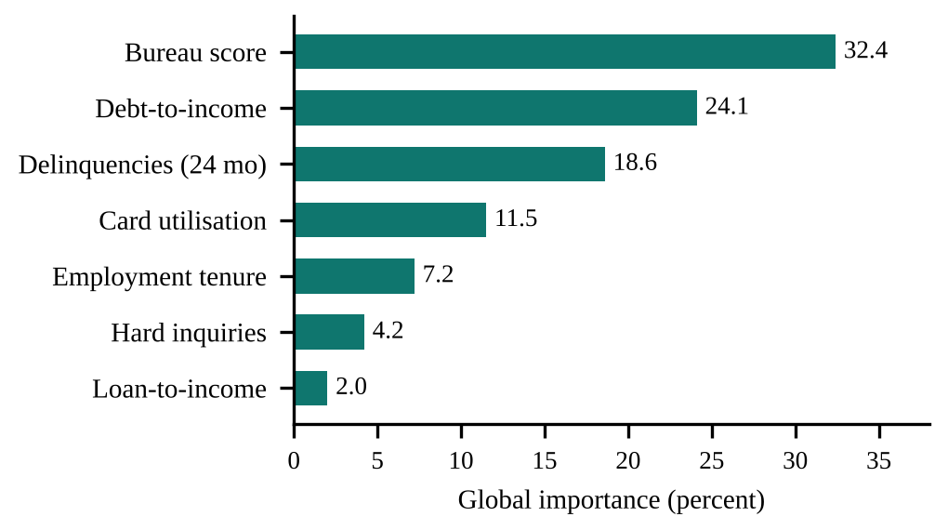
- Global feature importance used in the benchmark view (reference values).

Synthetic Data and Evaluation Pipeline
Because real labeled lending data are confidential, a companion Python pipeline generates 10,000 synthetic applicants with a fixed random seed of 42. Credit scores are drawn from a normal distribution with mean 680 and standard deviation 75, incomes from a log-normal distribution, card utilization from a beta distribution, and delinquency and inquiry counts from Poisson distributions. DTI and LTI are engineered as in Section IV-A, a default label is drawn from a latent logistic risk function, and the pipeline prints the evaluation matrix of the three models and the mix of approved, referred, and rejected outcomes. The pipeline generates and labels the data and reports the benchmark matrix; it does not itself fit scikit-learn [13] or XGBoost models, a point taken up in Section VII.

Implementation
FinSight is a single-page application written in React 18 [14] and strict TypeScript 5, styled with Tailwind CSS, with Recharts for charts and Vite as the build tool. There is no server process: the decision layer is a set of pure TypeScript modules that run in the browser in milliseconds. The six modules are as follows.
- Portfolio analytics: key indicators, decision outcome mix, quarterly default-rate trend, grade distribution, and delinquency ageing, driven by simulated portfolio statistics.
- Live underwriter: a bank-style intake with KYC, bank-statement, loan, and bureau sections, a model selector, and an instant decision banner with score, grade, PD, APR, limit, and top factors; a warning appears when verified inflows fall below 75 percent of stated income.
- Model benchmarks: metric cards and ROC, KS, and feature-importance views for the three models.
- Policy rules editor: toggles and threshold sliders for the rules and cut-offs, with an impact simulator.
- Batch ledger: a five-stage pipeline tracker, a decision table of all saved applicants with search and filters, sample ingestion, and CSV export.
- Academic showcase: a sixteen-slide walkthrough of the project.
The applicant ledger is held in React state and mirrored to localStorage, so saved applications survive a reload in the same browser. The production build is a static bundle that any static host can serve, and no API keys or environment variables are required. TypeScript strict mode ensures that mismatched fields between components and the shared types fail the build.

Results and Discussion
Evaluation was carried out at function level. A Node.js harness executed the project’s own TypeScript service modules unchanged, so the results below come from the real engine and not from a re-implementation. The built interface was also loaded in headless Chromium to confirm that each module renders, that a saved applicant can be loaded by search, that the audit certificate opens, and that a new application is saved to the ledger and survives a reload.

Benchmark Evaluation
Table V gives the benchmark evaluation matrix reported by the project. The champion gradient-boosted model separates defaulters best, with an AUC-ROC of 0.884 and a Kolmogorov–Smirnov (KS) statistic of 52.6 percent, against 0.832 and 46.1 percent for the random forest and 0.768 and 38.4 percent for logistic regression. This ordering is the one expected when non-linear interactions matter. These figures are reference values defined in the project’s code and printed by the pipeline, and they should be read as design benchmarks, not as measured results on held-out real data.
- Benchmark Evaluation Matrix (Reference Values)
Model | AUC-ROC | KS (%) | Precision | Recall | F1
XGBoost-style (champion) | 0.884 | 52.6 | 0.842 | 0.817 | 0.829
Random forest | 0.832 | 46.1 | 0.795 | 0.771 | 0.783
Logistic regression | 0.768 | 38.4 | 0.731 | 0.704 | 0.717

End-to-End Decisions for Ten Applicants
Table VI lists the champion engine’s output for the ten applicants of the batch module under the default policy. Four applicants (the prime, government-salaried, and long-tenure profiles) were approved with grades AAA or AA, and the AAA and AA approvals received a limit of 115 percent of the request, as designed. One applicant (APP-1006, DTI 51.7 percent, PD 9.94 percent) fell in the near-prime band and was referred with a counter-offer of Rs. 3,00,000, which is 75 percent of the request. Five applicants were rejected; APP-1004 triggered four knockouts (bureau score 540, DTI 85.4 percent, three delinquencies, and three cheque bounces), and APP-1007 triggered one (DTI 63.5 percent). Fig. 4 shows the champion PD of each applicant against the two policy cut-offs.
- Champion Engine Output for the Batch Applicants
ID | CIBIL | DTI (%) | PD (%) | Score | Grade | Decision
APP-1001 | 785 | 26.2 | 0.30 | 794 | AAA | Approved
APP-1002 | 668 | 48.4 | 32.08 | 612 | D | Rejected
APP-1003 | 625 | 38.0 | 74.81 | 546 | D | Rejected
APP-1004 | 540 | 85.4 | 88.00 | 513 | D | Rejected
APP-1005 | 810 | 31.2 | 0.30 | 794 | AAA | Approved
APP-1006 | 715 | 51.7 | 9.94 | 664 | BB | Referred
APP-1007 | 685 | 63.5 | 48.26 | 588 | D | Rejected
APP-1008 | 740 | 44.4 | 2.59 | 716 | AA | Approved
APP-1009 | 630 | 73.7 | 88.00 | 513 | D | Rejected
APP-1010 | 795 | 32.3 | 0.30 | 794 | AAA | Approved

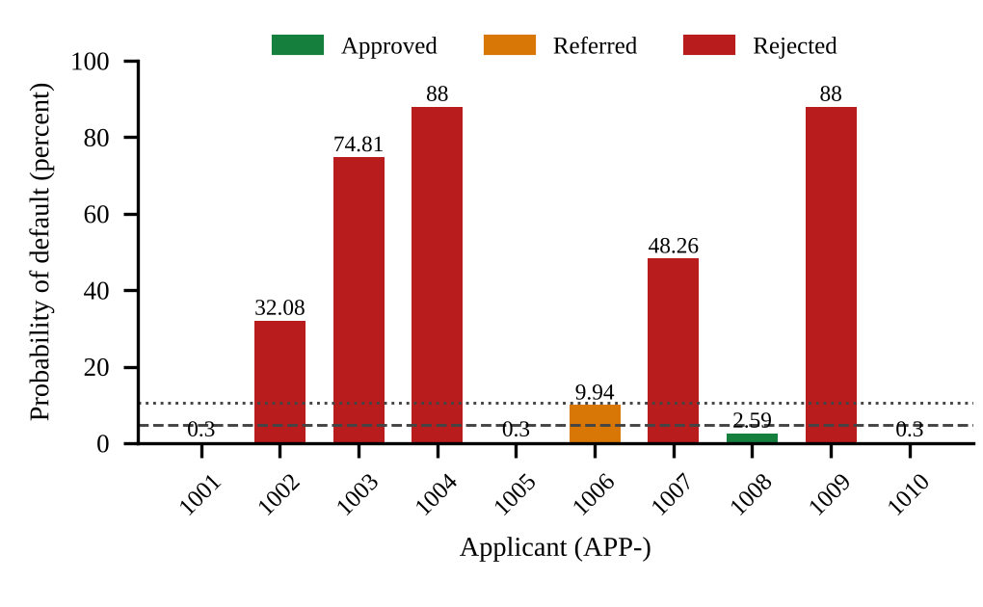
- Champion PD of the ten test applicants. Dashed line: auto-approve limit (4.8 percent); dotted line: auto-reject limit (10.5 percent).

Boundary and Configuration Tests
Twenty-nine test cases covered rule boundaries, policy configuration, limits, scoring, and the interface. Twenty-eight behaved as specified; the remaining case is an observation rather than a pass or fail check. Thresholds are applied exactly at their boundaries: a bureau score of 579 triggers the knockout and 580 does not, two delinquencies do not trigger the rule that fires at three, and a single cheque bounce does not trigger the knockout whereas two do. Disabling a rule removes it from evaluation, rejected applications receive zero limit and tenure, the PD is bounded between 0.3 and 88 percent, a PD of 0.3 percent maps to a score of 794, and PD values of 4.99 and 5.0 percent map to grades A and BBB. On the interface side, saving an application and reloading the page left the ledger at eleven rows, and ingesting a sample batch raised it from eleven to thirteen.

Discussion
Four findings from testing deserve emphasis. First, knockout rules carry real weight: with all rules disabled, a prime profile whose bureau score was lowered to 540 was approved, because the other features remained strong and the PD stayed below the auto-approve limit, which supports keeping the knockout layer independent of the model. Second, model disagreement is visible: for one preset applicant the three models give PDs of 32.08, 20.10, and 38.50 percent, which shows why the model selector is useful for review. Third, banking terms affect only the champion: as cheque bounces rise from zero to two, the champion PD rises from 32.08 to 53.74 percent, and as the average balance falls from Rs. 3,00,000 to Rs. 10,000 it rises from 25.92 to 36.59 percent, while the other two models do not change, so the three models are not compared on identical information for bank-heavy profiles. Fourth, the champion is conservative for moderate-risk profiles: two seed applicants labeled as manual review and thin-file referral receive PDs of 32.08 and 74.81 percent and are rejected.
Taken together, the results show that the integrated pipeline behaves consistently at its policy boundaries and that explicit rules, model scoring, and explanation can be combined in one auditable workflow. FinSight should be regarded as a decision-support and analytics aid rather than a replacement for human underwriting judgment and regulatory oversight, since software cannot correct biased historical lending data, incomplete applicant documentation, or flawed lending policy.

Limitations
The current version is a prototype, and its limitations should be read together with the results above.
- Calibrated approximations, not trained models. The in-browser scorer uses hand-calibrated log-odds functions, and the benchmark metrics and curves are reference values; no model has been fitted and validated on held-out real data.
- Rule-based attributions. The factor attributions follow the additive logic of SHAP but are not computed Shapley values.
- Policy edits are not applied to the live engine. The rules editor drives only its impact simulator, which is a heuristic; the underwriter and ledger use the default rules.
- Simulated portfolio data. Dashboard figures such as 14,850 applicants, a 68 percent approval rate, and a 3.1 percent default rate are simulated constants, not computed from the engine.
- No server, authentication, or live integrations. The ledger lives in the browser’s localStorage, bank-statement fields are typed in rather than verified through bureau or account-aggregator interfaces, identity and account numbers are stored unencrypted in the browser, and the verification fingerprint on the certificate is a fixed display value.
- Fairness not assessed. No bias or disparate-impact testing has been carried out on the scoring features.

Future Enhancements
The limitations above define a concrete path to a production-grade system. The most important step is to fit logistic regression, random forest, and XGBoost models with scikit-learn [13] and XGBoost [11] on real or public credit data, report measured metrics on a hold-out set, and replace the rule-based attributions with computed TreeSHAP values. Other planned work includes verified bank-statement ingestion through account-aggregator or bureau interfaces, wiring the policy editor into the live engine with policy versioning, a REST service with a relational database, authentication with role-based access and a signed audit trail, drift monitoring with the population stability index, fairness and disparate-impact testing, alternative data signals such as goods and services tax invoicing, utility payments, and unified payments interface transaction velocity, and an extension from PD to loss-given-default and exposure-at-default for expected-loss modeling.

Conclusion
This paper presented FinSight, an enterprise credit risk analytics and automated loan underwriting engine that combines feature engineering, selectable probability of default models, risk-based scoring and pricing, configurable policy decisioning, and factor-level explainability in one workflow. The engine is implemented as a six-module web application with a companion synthetic-data pipeline, and testing of its real service modules showed that scores, grades, limits, and decisions are produced consistently and that policy thresholds are applied exactly at their boundaries.
The reviewed literature demonstrates the value of alternative-data credit scoring, explainable AI, model benchmarking, and structured-data risk frameworks, usually studied separately. The main contribution of FinSight is their integration at a manageable project scale, with emphasis on transparency, policy configurability, and portfolio-level monitoring. The reported benchmark figures are design references rather than measured results, so the next step is to replace the calibrated approximations with models trained and validated on real lending data.

Acknowledgment
The authors thank their guide, Dr. N. Sunanda, Associate Professor, Department of Computer Science and Engineering, Koneru Lakshmaiah Education Foundation, for guidance and support throughout this work.

References
- Basel Committee on Banking Supervision, “International convergence of capital measurement and capital standards: A revised framework,” Bank for International Settlements, Basel, Switzerland, 2006.
- Reserve Bank of India, “Guidelines on digital lending and fair practices code for lenders.” [Online]. Available: https://www.rbi.org.in
- R. Abi, “Machine learning for credit scoring and loan default prediction using behavioral and transactional financial data,” World Journal of Advanced Research and Reviews, vol. 26, no. 3, pp. 884–904, 2025, doi: 10.30574/wjarr.2025.26.3.2266.
- Shreya and H. Pathak, “Explainable artificial intelligence credit risk assessment using machine learning,” arXiv:2506.19383, Jun. 2025, doi: 10.48550/arXiv.2506.19383.
- V. Chang, S. Sivakulasingam, H. Wang, S. T. Wong, M. A. Ganatra, and J. Luo, “Credit risk prediction using machine learning and deep learning: A study on credit card customers,” Risks, vol. 12, no. 11, p. 174, 2024, doi: 10.3390/risks12110174.
- A. Akinjole, O. Shobayo, J. Popoola, O. Okoyeigbo, and B. Ogunleye, “Ensemble-based machine learning algorithm for loan default risk prediction,” Mathematics, vol. 12, no. 21, p. 3423, 2024, doi: 10.3390/math12213423.
- N. J. Gade and P. L. Kunwar, “A machine learning framework for predictive credit risk assessment and loan default detection,” International Journal of Engineering Research & Technology (IJERT), vol. 14, no. 2, 2026, doi: 10.17577/IJERTCONV14IS020014.
- S. M. Lundberg and S.-I. Lee, “A unified approach to interpreting model predictions,” in Advances in Neural Information Processing Systems 30, 2017.
- D. W. Hosmer, S. Lemeshow, and R. X. Sturdivant, Applied Logistic Regression, 3rd ed. Hoboken, NJ, USA: Wiley, 2013.
- L. Breiman, “Random forests,” Machine Learning, vol. 45, no. 1, pp. 5–32, 2001.
- T. Chen and C. Guestrin, “XGBoost: A scalable tree boosting system,” in Proc. 22nd ACM SIGKDD Int. Conf. Knowledge Discovery and Data Mining, 2016, pp. 785–794.
- N. Siddiqi, Credit Risk Scorecards: Developing and Implementing Intelligent Credit Scoring. Hoboken, NJ, USA: Wiley, 2006.
- F. Pedregosa et al., “Scikit-learn: Machine learning in Python,” Journal of Machine Learning Research, vol. 12, pp. 2825–2830, 2011.
- React documentation. [Online]. Available: https://react.dev

